Zigbee – a standard communications protocol for low-power, wireless mesh networking.

Xbee- a brand of radio that supports a variety of protocols including Zigbee, 802.15.4, Wifi and others.

* Routing
* Ad Hoc Network Creation
* Self Healing Mesh
* Three types of “players”
  + Coordinator
  + Router
  + End Device
* Network Topology
  + Pair
    - Two radios
  + Star
    - Coordinator with a circle of end devices
  + Mesh
    - Multiple Routers
  + Cluster
    - Backbone of routers (similar to Mesh)

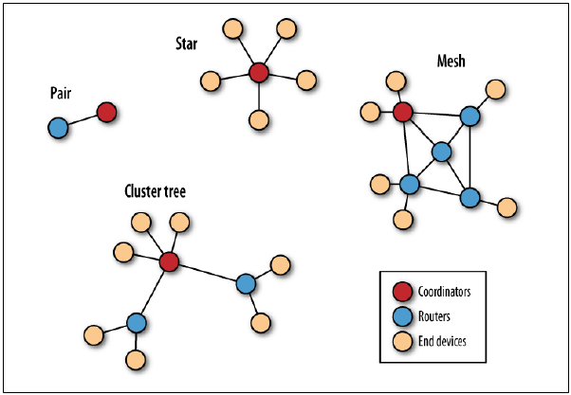

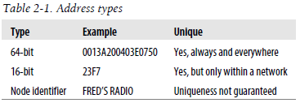

* Addressing
  + PAN Address
    - 16 bit
    - Equivalent to “City” in an address
    - Ultimately the address of the localized network
  + Channels
    - Frequency
    - Xbee handles that automatically
* Command Mode and Transparent Mode
  + AT
    - Transparent Mode
      * Talk through the Xbee
      * Any Data Can be sent through
      * Default State
      * Wait 10 seconds to return to this mode
    - Command Mode
      * Talk to the Xbee itself
      * Only responds to AT commands
      * +++ to eneter mode
      * Times out after no input for 10 seconds
  + API
    - Something about computers talking to one another in a way people don’t understand
* Xbee Direct
  + Independent input/output functions that do not require an external microcontroller.
  + Benefits
    - Reduces Size and Weight Constraints
    - Reduces Power Requirements
    - Saves Money
    - Often Least Complicated
  + Limitations
    - NO analog Output (but really most microcontrollers really don’t anyways)
    - No Logic (All logic would have to occur at the coordinator terminal)
  + Pins

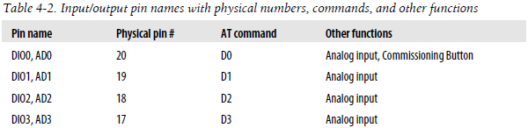

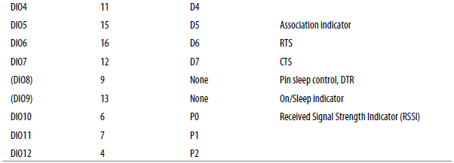

* + To Configure Xbee for direct IO, AT commands are required (They really push this in here).
* API Protocol
  + 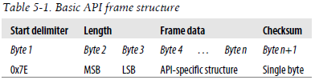
* Our Circuit
  + Analog Input
    - The output of the accelerometer will be in the 3.3v range and the input for the direct input of the Xbee radio microcontroller is only 1.2v, therefore a voltage divider. Therefore a voltage divider will be needed

$$V_{out}=\frac{R_{2}}{R_{1}+R_{2}}×V_{in}$$

$$1.2=\frac{R_{2}}{R_{1}+R_{2}}×3.3v$$